**Qualifying Trade Conditions With 10 Year Yields**

How do you know the seasonal tendency is liekly to occur? First qualify the swing in relation to the dollar index, so in the 1O year T were making lower lows, so in the dollar ideally we want to see a serie of higher highs. But at the same moment we can see that the dollar is making lower highs so we have SMT a crack in correlation, so that means theres a trade idea unfolding in the 1O year T against the dollar index, its further confirmed by seeing the interest rate market declining at that time as the yield declines, the futures price on the 1O year note was rallying

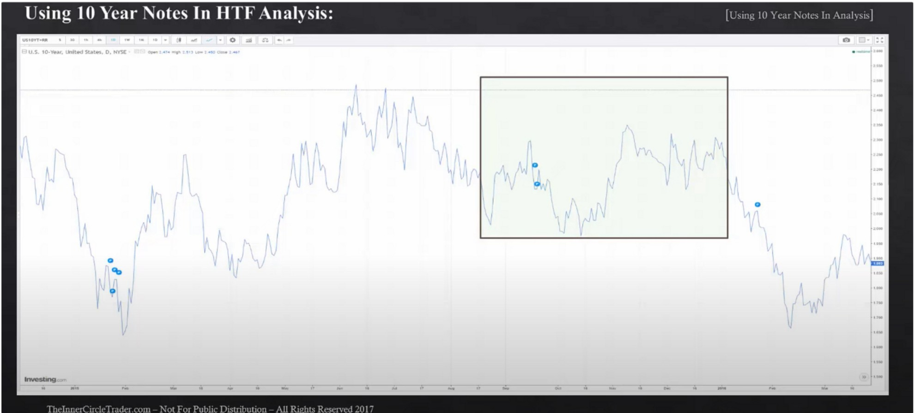

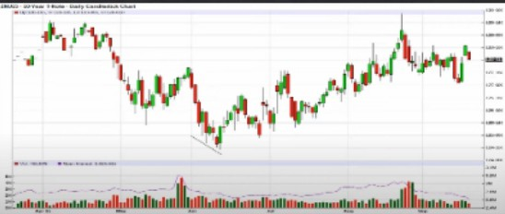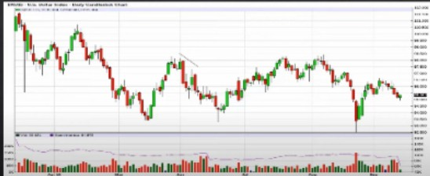

Note also the consolidation the yield stayed in which also led to a consolidation in the dollar index, 10 year note and foreign currencies at the same time.

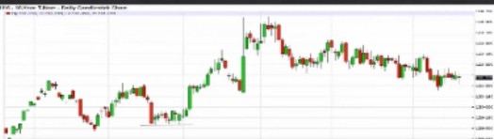

...·-- -·

**,1. ·•P1**

·-·-

*l\.d ,,,*,.,.r'4 -, *t \ llt1*

::

*T*

1O year note had EQLs, so we should see EQHs in dollar, but the dollar made higher highs so theres a crack in correlation, so theres an underlying trade idea underway. And this is further confirmed by seeing a decline in the 1O year yield

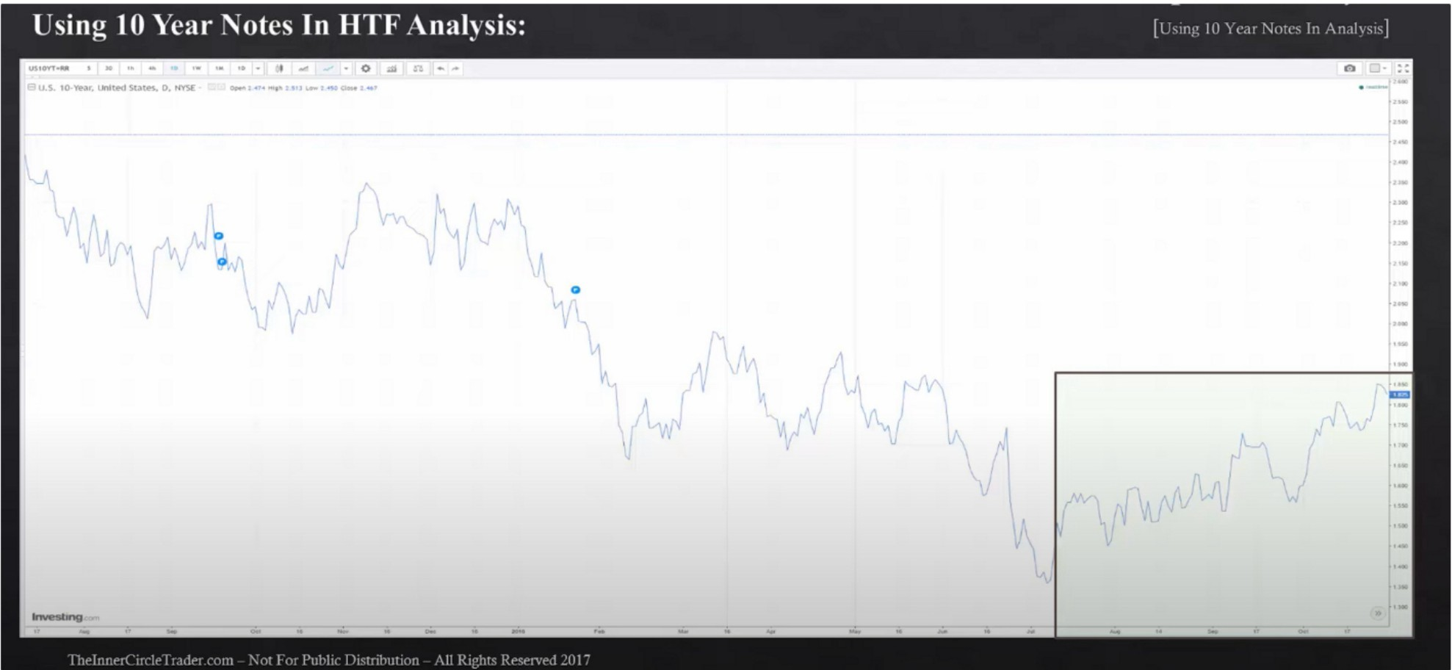

And again notice the consolidation, and its a contributing factor as to why the currencies had consolidation

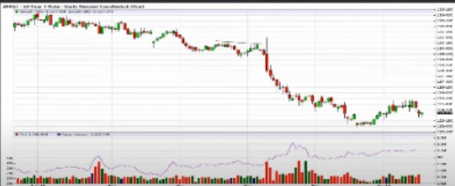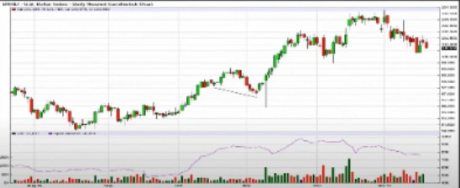

[

Lower high on the 10 year T note so dollar should be having higher lows, but infact we see a lower low. So for the dollar index seeing a lower low, that means we shouldve seen a higher high on the 10 year note, that didnt happen. So again a crack in correlation. There should be a perfect symmetry, when that symmetry is broken it indicates that theres an underlying trend or manipulation underway. We also see the open interest decline, supporting the idea that there was short covering in the dollar index. The idea is supported also with the increase in the 10 year bond interest rates, interest rates increasing so the dollar has a strong tendency to rally as well

When we see these things happen in price we want to blend the idea with quarterly shifts, so if were looking for the next 3/4 month swing, generally the trade idea comes to fruition in 1.5 months and complete. Sometimes it will go full duration. Generally ICT looks for 3 month trends

Go in and look at these times when seasonal tendencies align and theres qualifying SMT DIV between the dollar index and 10 year note, when they have that pattern you can also qualify it with a interest rate triad or a foreign currrency pair against the dollar index. This will give you an idea for a quarterly shift. When these tools are in alignment, it gives your trades high probability and it filters out a lot of the noise, even if you dont trade long term you can use this do get in sync with institutional orderflow, then its very hard to go wrong

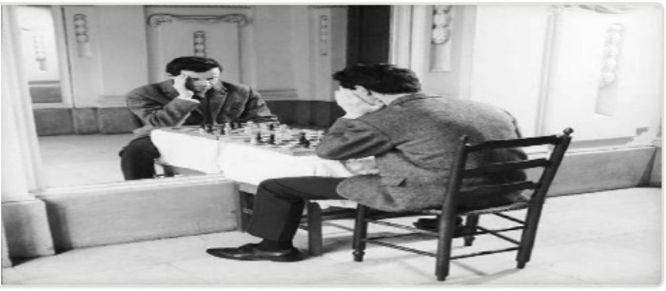Arjo I Twitter, lnstagram I Linktree

Linktree. Make your link do more.

1 https://1.co/HhmmTN1fUI

JavaScript is not available.

*"'JI* https://twitter.com/arjoio